**INTEGRATED AGRICULTURAL SYSTEM-VYAVASAY**



**Pre cultivation:**

* Each and every farmer will be provided with VUIN-vyavasay unique identification number, which do consists of the information of the farmer and linked with the UIDAI, by this we could know the bank account information of the farmer, and biometrics of the farmer

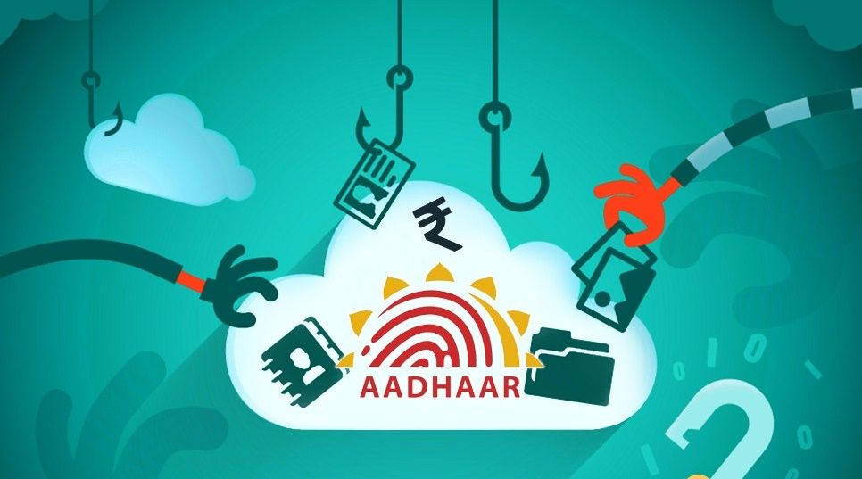

* This VUIN does consists of the geometrics of the land and the soil reports of the respective land(recent one)
* Water table is constructed to each and every land, in this water table the sources of the water is estimated such as surface runoff/ground water/rainfall.
* Water table is constructed in such a way that ground water conservation is the main motto, soak pits and other ground water conservation techniques are planned according to the topography.
* And according to the availability of the water (from water table) and by the interpretation of the soil test reports the suitable crop is decided and farmer is intimated to grow that crop in the land.
* While buying of the seeds of the crop the farmer should place the biometrics in the shop, by this we could able to know the batch number of the seeds and manufacturer and other things, if in case the seeds are fake/quality less the needed action could be taken as we could know the origin of the seeds.



* This system is applicable while the purchase of fertilizers and pesticides.
* Farmers could easily get the loans sanctioned by the bankers as they can reference our vyavasay system
* The central and state government welfare schemes can be directly credited to the beneficiary farmer account
* The subcidies for the solar pump sets, drip irrigation equipment, sprinkler system can be sanctioned for the needful by referring to the water table.

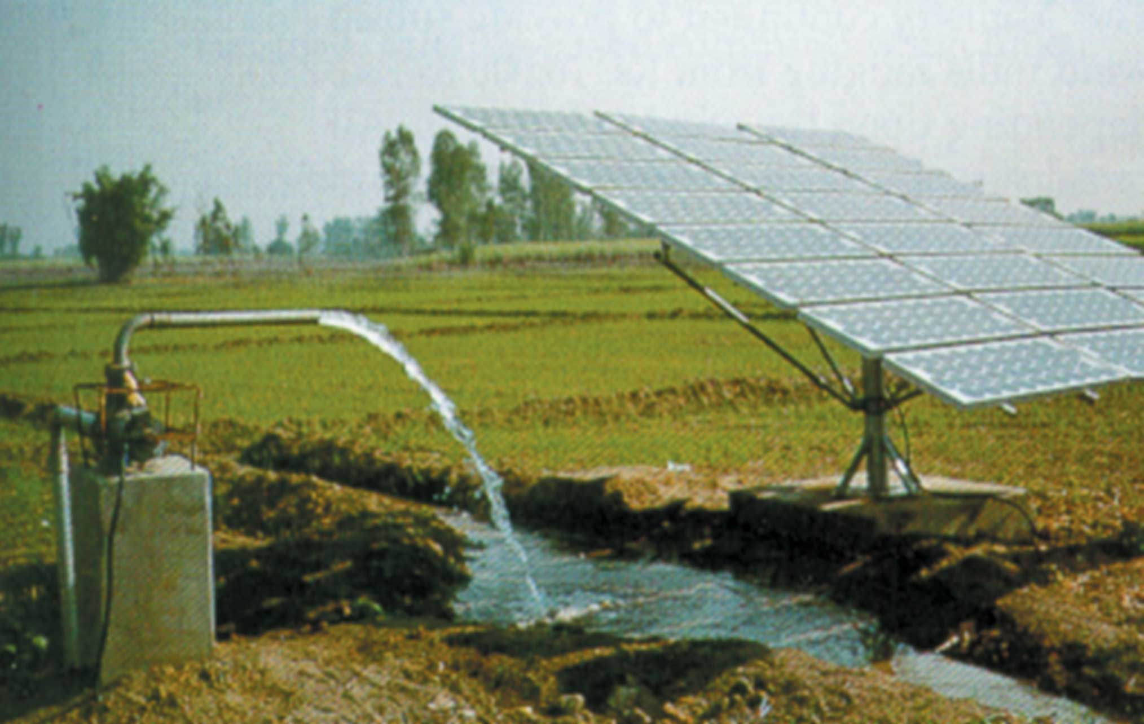

* Zero budget farming and other kinds of natural resource enhancing kinds of farming’s are encouraged.

**Cultivation:**

* The pre preparation of the agricultural land is done by the farmer with the help of the world class agricultural instruments that are provided at the instrumentation centre at the VYAVASAY centre which was placed according to the agriculture density in that region, the instruments are provided to the farmers in slot basis.
* The skilled labour required to operate the agricultural instruments are provided by the vyavasay centre itself.
* The cultivation is inspected for every 3-7 days either by manual inspection or drone inspection and the farmers were educated to improve the process of cultivation.
* If the crop requires additional fertilizer the vyavasay team informs the farmer to use the specific type of fertilizers and they also explains how to apply fertilizers to the crop in affective manner.

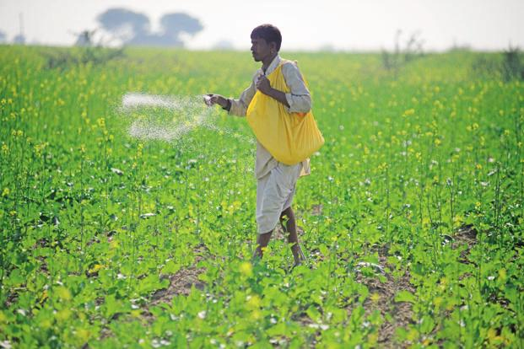

* For example in general the farmer’s very well-known fertilizer was the urea, but every crop doesn’t require the urea.
* For the effective pest control over the crop the respective pesticide is informed to the farmer and the effective method of the application of the pesticide to the land is carried out by the guidance of the vyavasay team.
* The water head maintenance is also plays crucial role in this stage.

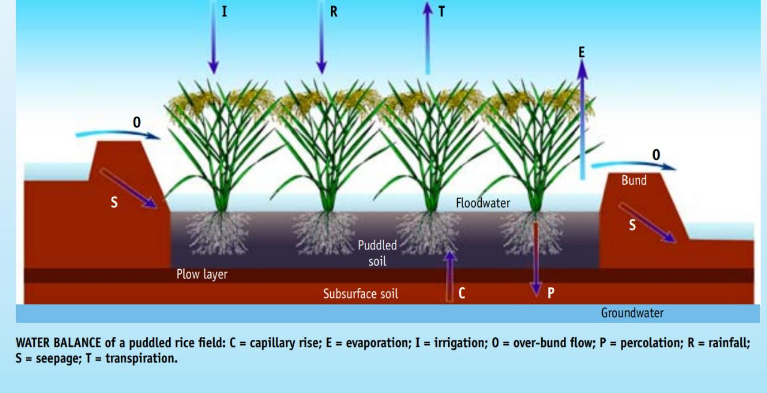

* For example the farmers have a misbelief that high the water head maintained in the paddy field high will be the yield but according to the research work if the water head is high than the required the yield will be decreased.
* An average Indian farmer consumes 15000 lit per kilogram of the paddy while only 0.8 lit is sufficient for the cultivation of the paddy (By Indian agricultural research institute-new Delhi). This effects the paddy crop and the livelihood of the citizens by drowning of the more water from the ground water, sates like AP, PUNJAB should concentrate more upon the maintenance of the water head in the land.as the India is at the edge of the water crisis, as by NITI AAYOG report by 2025 every 6 members in 10 members in India could able to get the drinking water.

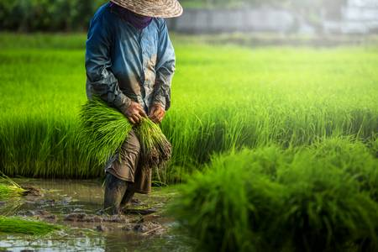

**Post cultivation:**

* The crops from each VUIN are estimated.
* The crops are handover at the vyavasay centre and the MSP is directly credited to the farmers account.

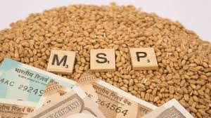

* The crop is further proceed to quality check and the crop is sorted according to the quality, according to the demand the crop may be transported or stored in the godowns available in the vyavasay centre.
* The cold storage godowns and godown was built-up according to the area's requirement.

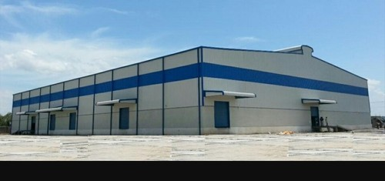

* The VYAVASAY system will export the crop and manage the local markets according to the demand in the state, if surplus amount of demand is in stake the VYAVASAY will import and market them.
* The balance amount of the crop will be credited to the farmers account after the sold out the respective crop into the bank account directly.

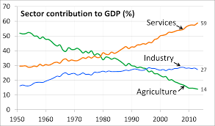

**Uses:**

* Digitalisation of the market-the market demand was digitalised and VYAVASAY system could meet the demand by supply of source.
* Profit for the farmer-as we are making scientific agriculture the yield will be high and by the proper marketization the farmer can get high profits.
* VYAVASAY is based upon the cloud computing.
* Enhancing the digital banking-as the transactions are totally carried out through digital it will bring a growth in the banking sector.
* Easy capital generation- loans by the bankers can be easily sanctioned.
* Welfare schemes-beneficiaries could easily get the welfare schemes.
* World class agriculture-as we are using world class equipment we could able to get high qualitative yield which can be exported by huge profits.
* Water conservation-we can conserve the water by utilising the minimum amount of the ground water and the surface water can be utilised in a proper manner.
* Growth in GDP-by this system the rate of agriculture increases which will enhances our GDP growth and we could easily achieve the 5trillion dollar economy.
* Crop regulation-by this system we could get crop regulation in the state.
* E-commerce can be utilised for the marketing.
* quick compensation-in times of the natural disasters the compensation can be calculated, an aerial survey can demonstrate the effective lands and we can interpret the geometrics with VUIN, we have a proper estimation of the crop in the respective lands and the compensation can be directly credited to the bank accounts of the farmer.
* Growth in Agro based industries-we could able to increase the agro based industries as the requirements of the companies are satisfied.
* Easy claiming of insurance (agricultural).

